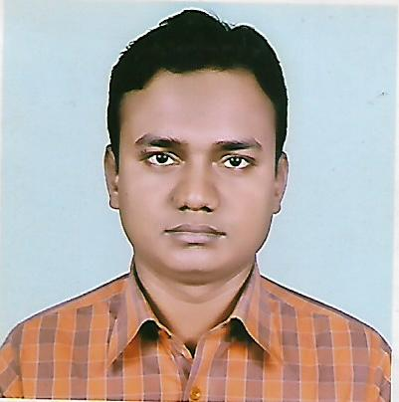**Curriculum Vitae**

**Of**

**MD. SIRAJUL ISLAM**

**Present Address:**

Ershad Nagor, Cadet College, Rangpur.

Cell: 01755-463868

**Career Objective**

To build up the career in a renowned and promising organization, where have an excellent career development prospect and challenging environment. I believe that hard work, strict discipline, good communication and creative problem solving skills are the cornerstone of success.

**Academic Background:**

**Diploma in Engineering**

Institute : Rangpur Polytechnic Institute

Department : Power

Duration : Four Year

Result : C.G.P.A- 3.64 (Out of 4.00)

Passing Year : 2014.

Board : Dhaka.

**Secondary School Certificate (S.S.C)**

Institute : Rangpur Technical School & College.

Department : Electrical.

Result : G.P.A- 4.59 (Out of 5.00)

Passing Year : 2009

Board : Dhaka.

**Skills and achievements**

**Computer**  : Excellent Computer in MS Word, Excel,

Access & Internet Browsing.

**Language Proficiency** : Have an excellent command over Bangla &

English in both oral & Written.

**Interest** : Reading, Writing & Traveling.

**Experience**  : 1. Industrial Training (3-Month) from BRTC

Gazipur, Dhaka.

2. Manager, Unique Auto Mobile Engineering

Workshop. Mohakhali, Dhaka.

(1st Jun-2014 to 17th Nov-2014)

3. Junior Service Engineer, Ranks Motors

Workshop Ltd. (22nd Nov-2014 to 04th Aug-16)

Murolir mour , Benapole Road, Jessore.

3.Service Engineer, TVS Auto Bd Ltd.

Rangpur Workshop (05th Aug-16 to still now)

**Personal Information :**

Father’s Name : Md. Sahab Ali.

Mother’s Name : Most. Shafali Begum.

Date of Birth : 18th Jun 1993.

Permanent Address : Vill- Arshad Nagar, P.O- Cadet College

P.S- Kotoali Thana, Dist- Rangpur.

Sex : Male.

Marital Status : Unmarried.

Religion : Islam

Nationality : Bangladeshi (by Birth)

**Reference**

Md. Nabej Uddin.

Md. Shafiqul Islam.

Instructor, Power

Rangpur Polytechnic Institute

Bangladesh.

Cell: 01719-244344.

Chief Instructor, Power

Rangpur Polytechnic Institute

Bangladesh

Cell: 01913-911000

MD. SIRAJUL ISLAM

Date:-17/01/2018